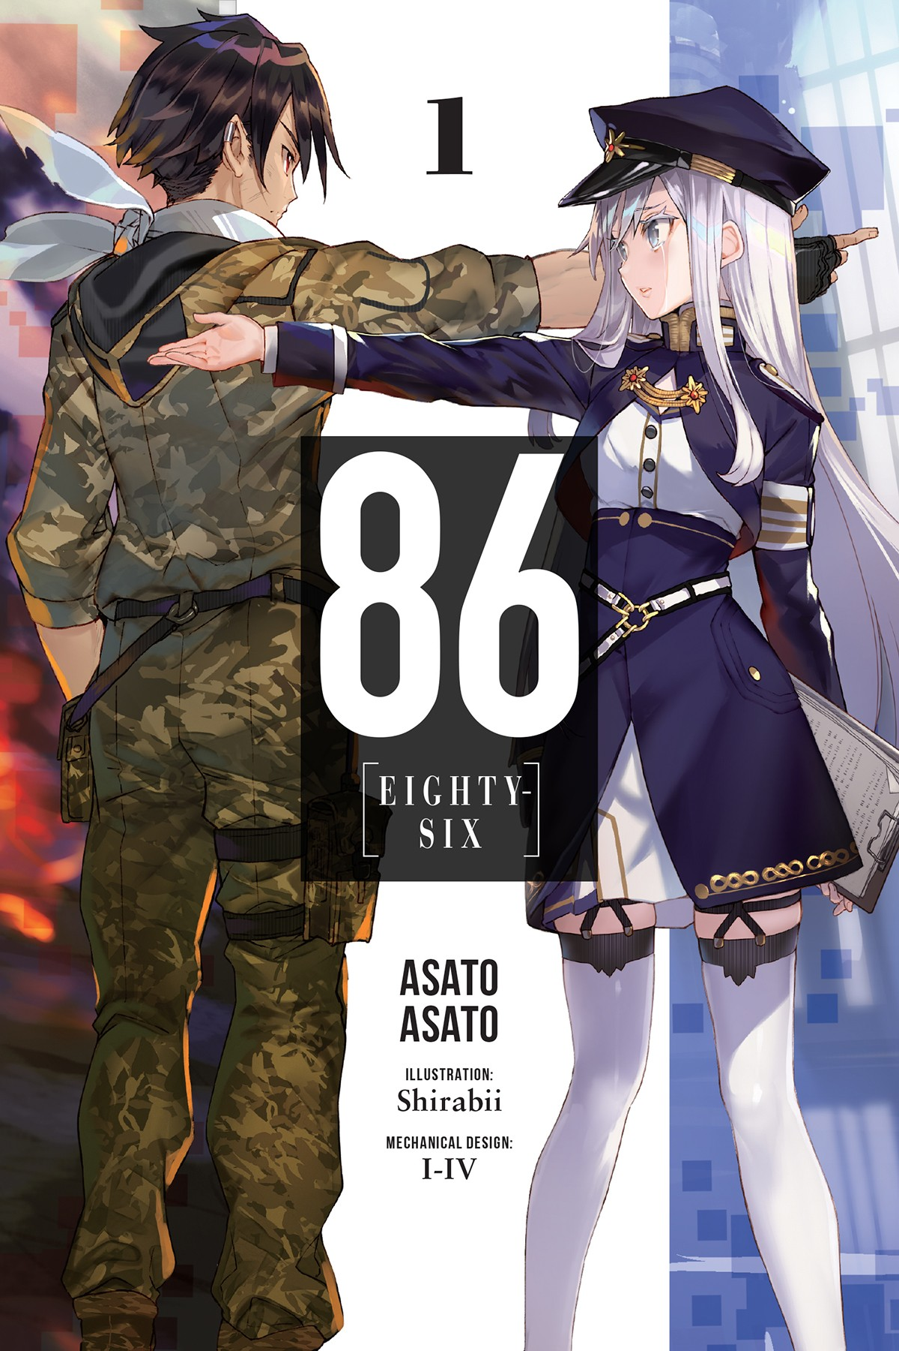

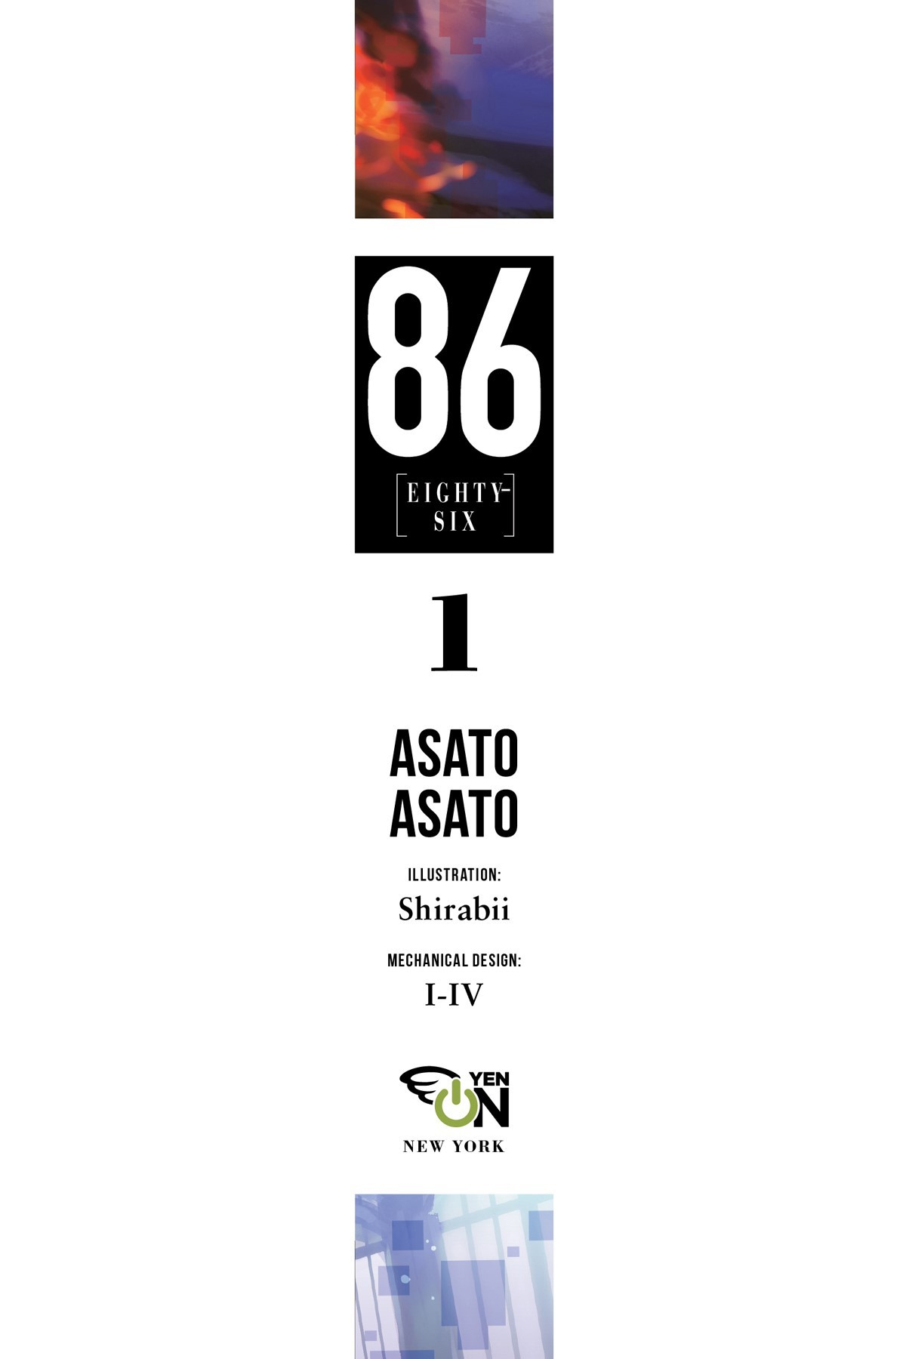
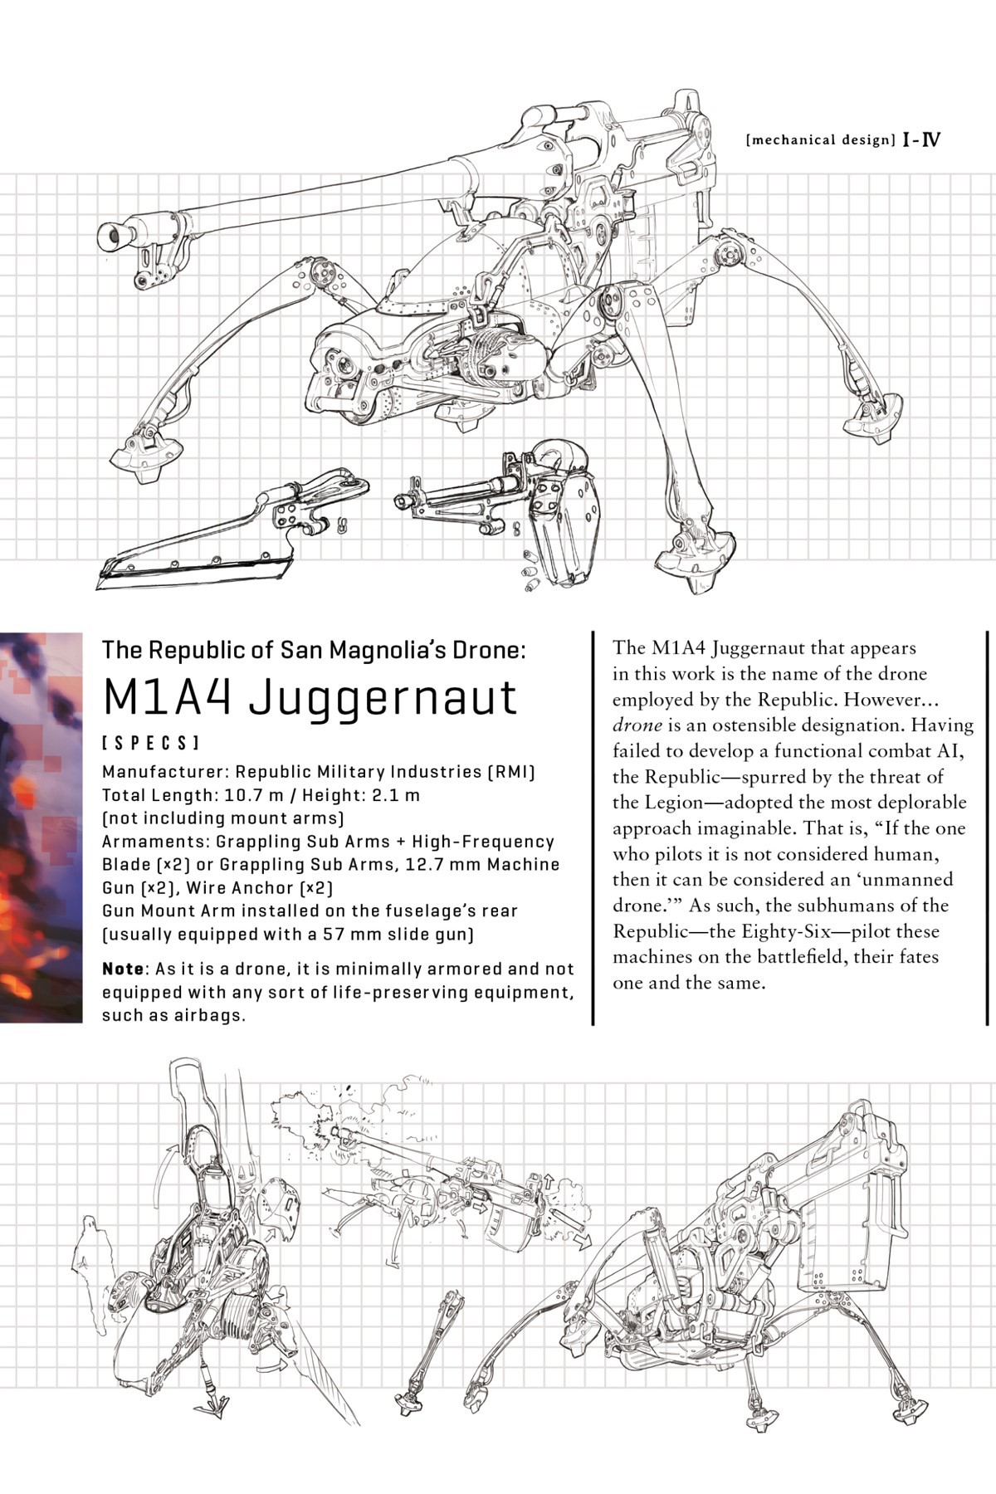
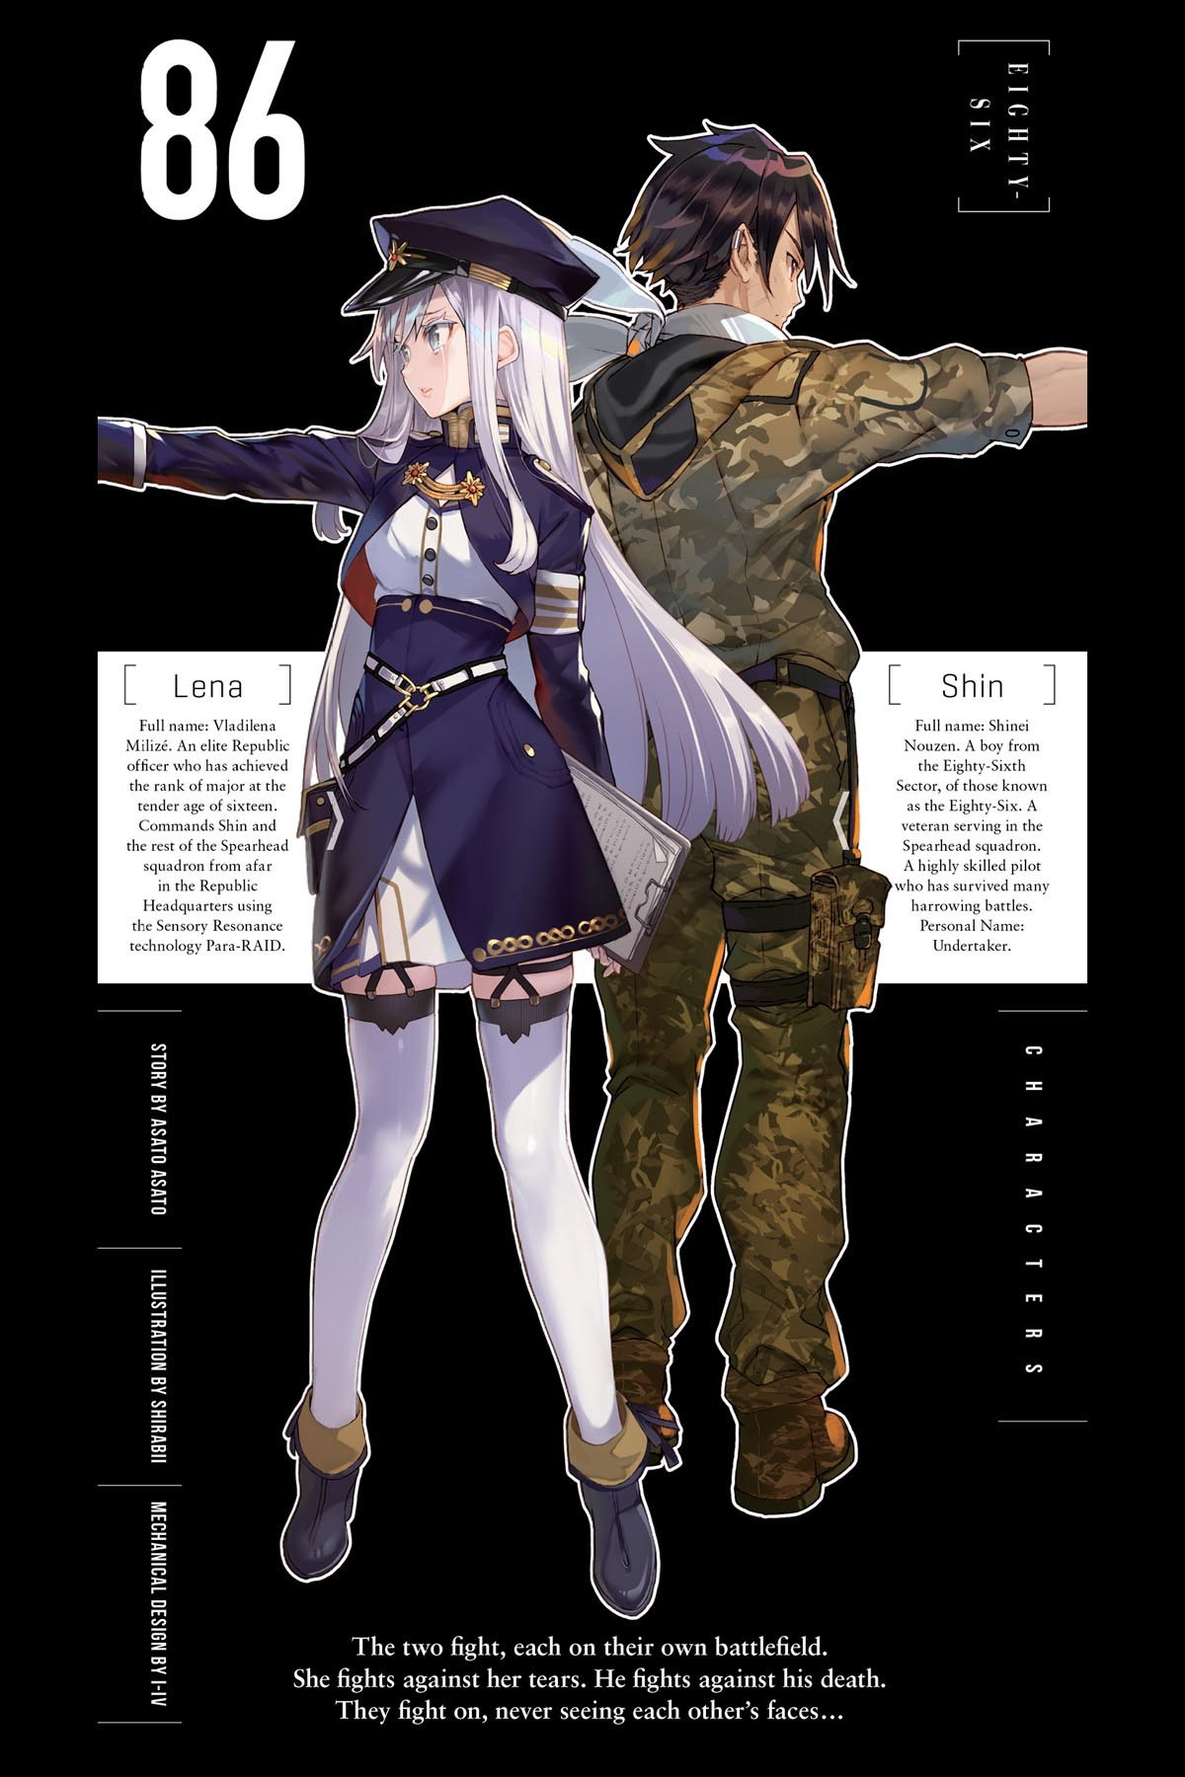

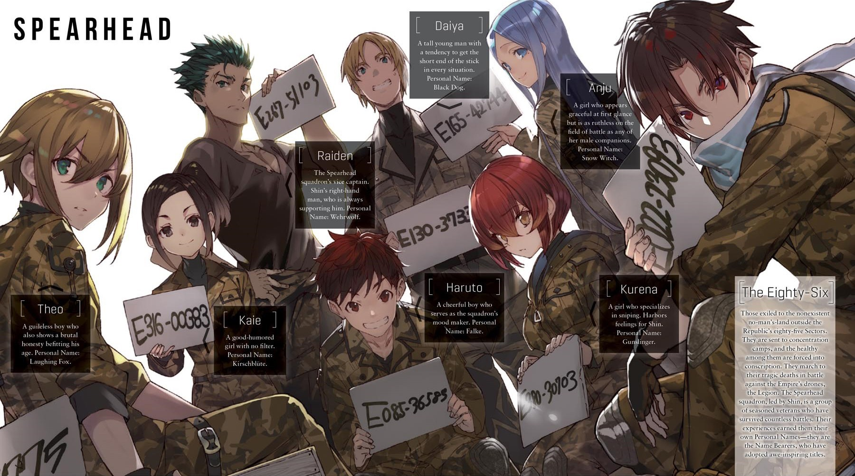

Copyright

86—EIGHTY-SIX
Vol. 1
ASATO ASATO
Translation by Roman Lempert
Cover art by Shirabii
This book is a work of fiction. Names, characters, places, and incidents are the product of the author’s imagination or are used fictitiously. Any resemblance to actual events, locales, or persons, living or dead, is coincidental.
86—Eighty Six— vol. 1
Copyright © ASATO ASATO / KADOKAWA CORPORATION 2017 First published in Japan in 2017 by KADOKAWA CORPORATION, Tokyo.
English translation rights arranged with KADOKAWA CORPORATION, Tokyo, through TUTTLE-MORI AGENCY, INC., Tokyo.
English translation © 2019 by Yen Press, LLC
Yen Press, LLC supports the right to free expression and the value of copyright. The purpose of copyright is to encourage writers and artists to produce the creative works that enrich our culture.
The scanning, uploading, and distribution of this book without permission is a theft of the author’s intellectual property. If you would like permission to use material from the book (other than for review purposes), please contact the publisher. Thank you for your support of the author’s rights.
Yen On
1290 Avenue of the Americas New York, NY 10104
Visit us at yenpress.com facebook.com/yenpress twitter.com/yenpress yenpress.tumblr.com instagram.com/yenpress
First Yen On Edition: March 2019
Yen On is an imprint of Yen Press, LLC.
The Yen On name and logo are trademarks of Yen Press, LLC.
The publisher is not responsible for websites (or their content) that are not owned by the publisher
Library of Congress Cataloging-in-Publication Data
Names: Asato, Asato, author. | Shirabii, illustrator. | Lempert, Roman, translator.
Title: 86—eighty-six / Asato Asato ; illustration by Shirabii ; translation by Roman Lempert.
Other titles: 86—eighty-six. English
Description: First Yen On edition. | New York, NY : Yen On, 2019– Identifiers: LCCN 2018058199 | ISBN 9781975303129 (v. 1 : pbk.) Subjects: CYAC: Science fiction.
Classification: LCC PZ7.1.A79 .A18 2019 | DDC [Fic]—dc23
LC record available at https://lccn.loc.gov/2018058199
ISBNs: 978-1-9753-0312-9 (paperback)
978-1-9753-0313-6 (ebook)
E3-20190513-JV-PC-COR
Contents
Cover
Title Page
Insert
Copyright
Epigraph
Coquelicots Blooming Across the Battlefield
Chapter 1: A Battlefield with Zero Casualties
Chapter 2: All Quiet on the Skeletal Front
Chapter 3: To Your Gallant Visage at the Underworld’s Edge
Interlude: The Headless Knight
Chapter 4: I Am Legion, for We Are Many
Interlude: The Headless Knight II
Chapter 5: Fuckin’ Glory to the Spearhead Squadron
Interlude: The Headless Knight III
Chapter 6: Fiat Justitia Ruat Caelum
Interlude: The Headless Knight IV
Chapter 7: Good-bye
Epilogue: The Bloodstained Queen’s Sojourn
Epilogue II: Reboot
Afterword
Yen Newsletter
No country would ever consider it an act of evil to deny a pig human rights.
Therefore, if you were to define someone speaking a different tongue, someone of a different color, someone of a different heritage as a pig in human form, any oppression, persecution, or atrocity you might inflict upon them would never be regarded as cruel or inhumane.
—VLADILENA MILIZÉ, MEMOIRS
COQUELICOTS BLOOMING
ACROSS THE BATTLEFIELD
<System Start>
<RMI M1A4 Juggernaut OS Version 8.15>
A rumbling cacophony mixed into the noise of the radio transmission.
“Handler One to Undertaker. Enemy interception force is visible on radar. We’ve confirmed a battalion-size unit of Anti-Tank Artillery types as well as a force of Dragoon types of similar size.”
“Acknowledged, Undertaker. I can sense them from here.”
“Command is transferred to the commanding officer on the field, effective immediately. Show gratitude to your homeland with your flesh and blood and defend the Republic with your very life.”
“Roger.”
“…I’m sorry, you guys. I’m so sorry.”
<End transmission>
<Cockpit sealed>
<Power pack activated. Actuator engaged. Joint-lock mechanism released.>
<Stabilizer: operating normally. FCS: compatible. Vetronics: off-line. Enemy scouting mode: passive.>
“Undertaker to all units. Handler One has relinquished command. Henceforth, Undertaker will take command of the operation.”
“Acknowledged, Alpha Leader. Same as always, right, Reaper? What did our cowardly wuss of an owner say in the end there?”
“That they’re sorry.”
The voice at the other end of the Para-RAID burst into laughter.
“Ha, those white pigs never change. They drive us out, lock us up, and then plug their ears and say they’re sorry? The hell… All units, you heard him. If we gotta march to our deaths anyway, at the very least, it might not be so bad with our trusty Reaper there to guide us.”
“Sixty seconds till contact with the enemy… The bombardment’s coming. Break through the enemy’s bombardment zone at maximum combat speed.”
“Let’s do this, boys!”
<Open Combat Maneuvers>
<Enemy Unit Detection set to Bogey 1> <Set to Bogey 2> <Bogey 3> <Bogey 4>
<Bogey 5> <Bogey 6> <Bogey 7> <Bogey 8> <Bogey 9> <Bogey 10> <Bogey 11>
<Bogey 12> <Bogey 13> <Bogey 14> <Bogey 15> <Bogey 16> <Bogey 17> <Bogey 18> <Bogey 19> <Bogey 20> <Bogey 21> <Bogey 22> <Bogey 23> <Bogey 24>
…
<Engage: Bogey 210>
“Delta Leader to Delta squadron! Don’t try running around—we’re taking them out here!”
“Charlie Three! Hostile on your ten! Dodge it— Shit!”
“Echo One to all units. Echo Leader KIA. Echo One taking over command.”
“Bravo Two to all units. Sorry… Looks like this is the end of the line.”
“Alpha Leader to Alpha Three! Hold on just a minute longer! I’m on my way! Alpha One, take over command for me.”
“Roger that. Good luck out there, Alpha Leader.”
“Thanks… Hey, Shin. Undertaker.” “What?”
“You still remember your promise, right?”
“…Yeah.”
<C1 Signal Lost>
<Friendly Units: 0>
The officer’s voice, mingled with static, issued from his removed headset and disturbed the dusk breeze.

“To…units… Handler One to all units. Do you read? Respond, first unit.”
He leaned against his unit’s fuselage—an organic-looking thing, similar to a chrysalis—and reached into the cockpit’s opened canopy and pressed the radio’s transmission button.
“Undertaker to Handler One. Enemy interception force exterminated. We’ve confirmed the enemy forces’ retreat. Operation complete. Returning to base.”
“…Undertaker. H-how many will be returning—?”
<End transmission>
It was a foolish question with nothing to be gained from an answer. Before the other person could finish speaking, he cut the transmission and returned his gaze to outside the cockpit.
The scene was illuminated by the sunset with a coquelicot glow, casting shadows on a battlefield littered with flickering flames and the remains of crouching metal beasts and quadruped spiders, mechanical viscera protruding from their frames. Those were the remains of friend, the remains of foe, the remains of everything.
Not a single trace of life remained on this battlefield except for him. Look as far as he might, all he would find would be corpses and the ghosts of those who lingered even after death. The silence was unsettling. Across the fields, the sun set into a shadowy mountain range, casting red, level rays of light his way.
In this dying world bathed in crimson, or perhaps dyed over by shadow, he and his unit were the one thing that could still move. The unit’s long limbs were designed after an insect’s arthropod legs. Its discolored armor was decorated with countless scars, and it was equipped with a scissorlike high-frequency blade and a back-mounted main armament.
Its silhouette was that of a prowling spider, but its quadruped nature and the cannon on its back likened it to a scorpion. Lacking anything that could be considered a head, its form was reminiscent of a beheaded skeletal corpse, crawling along the battlefield, searching for its missing crown.
Sighing a single breath into the air, he reclined against the armored fuselage as it cooled against the dusk wind, turning his gaze up to the terrifying brilliance of the sunset sky.
A distant eastern country once told of a flower born from the blood of the mistress of a great king, who ended her own life. Or perhaps that flower bloomed from rivers of blood spilled from knights butchered by barbarians.
The crimson of those coquelicots that blossomed as far as the eye could see, illuminated by the sunset that burned all to nothing, was as beautiful as sheer madness.

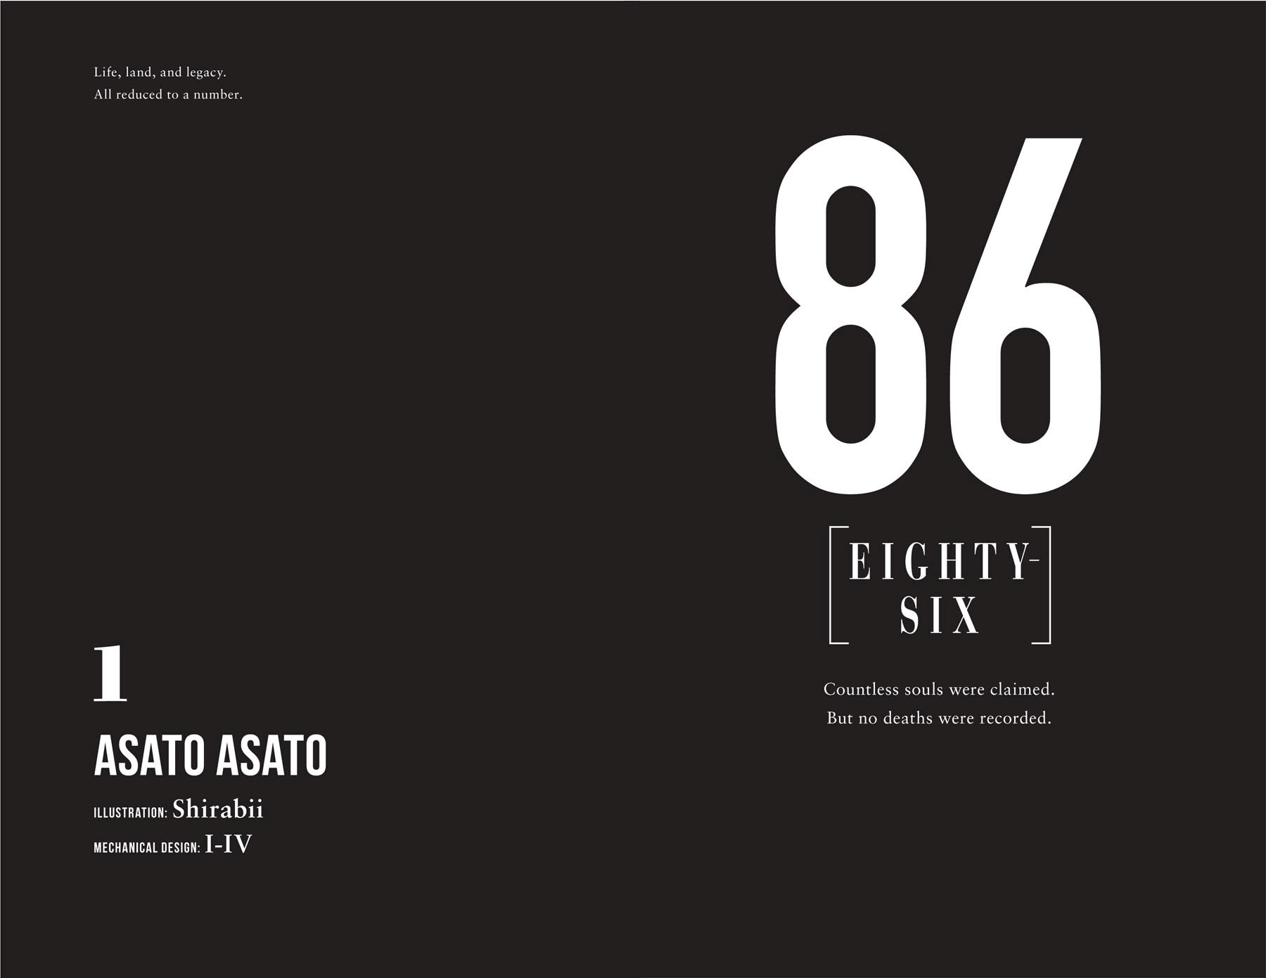

CHAPTER 1

A BATTLEFIELD WITH ZERO CASUALTIES
There were no casualties on that battlefield.
“—And now, we have an update regarding the war.
“A group of the unmanned Imperial weapons known as the Legion have invaded the seventeenth ward today. The force was intercepted, severely crippled, and forced to retreat by the might of our unmanned drones, the Juggernauts, pride and joy of the Republic of San Magnolia. Damage to equipment was light, and no loss of life was reported on our side today yet again.”
The main street of the Republic of San Magnolia’s capital, Liberté et Égalité, was so peaceful and beautiful one would be hard pressed to believe the country had been at war for the past nine years.
Carved white marble graced the facades of the city’s high-rise buildings. The greenery of the roadside trees and the black castiron lampposts mingled to create a picturesque contrast with the spring sunlight and the clear blue sky. The cafés on the street corners were populated by students and couples, their naturally silver hair glittering as they laughed loudly.
The city hall’s blue roof was adorned with a flag bearing the visage of the saint of the revolution, Saint Magnolia, and the Republic’s five-colored national flag. Its five colors stood for freedom, equality, brotherhood, justice, and nobility. The main street was paved with vast, delicately carved stones, the result of meticulous urban planning.
A young boy passed by Lena, his silver hair shining like the moon as he laughed, holding his parents’ hands. Dressed so neatly, they were probably going out somewhere. Sparing a final glance at the backs of the happy family, she turned her silver eyes to the street-side television’s holo-screen, the smile fading from her lips.
She was clad in the Republic military’s dark-blue collared uniform for female officers. The sixteen-year-old girl had a snowwhite beauty and a certain glasswork delicacy that fit her age— and an elegant demeanor that reflected her upbringing and pedigree. Her softly flowing, silken hair and long eyelashes were a striking silver, and her large, equally silver eyes served as proof of her being not only an Alba, a descendant of the race native to this land since ages past, but also a pureblood Celena, who were considered to be of noble birth.
“Under the capable command of our skilled Handlers, these highly efficient drones allow us to defend the nation while eliminating the need to dispatch precious lives to the front lines. There can be no doubting the usefulness of the Republic’s humane and advanced combat system. The day when the
Republic’s righteous ways defeat the fallen Empire’s evil relics will surely come even before the entire Legion shuts down in two years’ time. Hail the Republic of Magnolia. Glory to the five-hued flag.”
Lena’s expression darkened at the sight of the snowy-haired, silver-eyed alabaster newscaster’s brilliant smile. This optimistic, or rather unrealistic, news report had been repeated countless times since the war began, and the majority of civilians didn’t doubt its authenticity. They believed it in spite of the fact that after being driven out of more than half its territory less than a month into the war, the Republic had failed to regain any of it in nine years of fighting.
And all it took was one cursory look around this picturesque main street to notice a certain fact. It was evident in the newscaster, the couples and students in the café, the people passing by, and of course, even Lena herself. The Republic prided itself on being the first modern democracy in the world and proactively welcomed immigrants from other countries. The Republic had been the native land of the Alba since ages past, while other countries were home to people of different colors. All people of color, Colorata, were welcomed equally, be they the dark-as-night Aquila; the golden Aurata, who shone like the sun; the Rubela with their brilliant crimson hair; or the blue-eyed Caerulea.
But right now, if one was to scour the capital’s main street—no, even the city in its entirety—all one would find in the Republic’s eighty-five administrative Sectors would be silver-haired, silvereyed Alba.
Yes, formally speaking, there were no soldiers considered human or counted among the dead on the battlefield. However…
“…That’s not to say no one died.”

